A Comparative Analysis of Usability and Engagement In Static versus Animated Dashboard Interfaces

Mariah Buhagiar
Institute of Information Communication and Technology
Malta College of Arts, Science & Technology
Paola, Malta
mariah.buhagiar.g52824@mcast.edu.mt

Description of Theme and Topic Rationale

Dashboards have become widely used tools for presenting large and complex datasets, offering users a curated overview of the most relevant information across many domains, including business, public health, learning analytics, personal analytics, and finance [1]. This study will focus on financial dashboard interfaces, and within financial services, the demand for efficient and intuitive digital experiences is especially important, as users need interfaces that help them understand and engage with personal financial information more effectively [2]. As dashboard design becomes more sophisticated, features such as interaction, components, and visual presentation play an increasing role in shaping the overall experience.

At the same time, interface research shows that usability and user experience are strongly influenced by interface layout, information quality, and interaction logic [3]. Studies comparing static and dynamic visual formats also suggest that different presentation styles can shape how clearly information is communicated and how engaging it appears to users [4]. Therefore, this study explores how static and animated dashboard interfaces influence perceived usability and engagement within a financial dashboard context.

Positioning and Research Onion
This study delves into Human–Computer Interaction (HCI) and looks at how dashboard design affects the user experience. In particular, it explores whether animation changes how usable and engaging a dashboard feels, focusing on subjective user perceptions rather than only performance metrics.
To guide the methodology, the study uses Saunders et al.’s Research Onion framework, which helps organise and justify key choices made. The following sections outline and explain how each layer of the research, which is shown in Figure 1.

Research Philosophy
This research follows an interpretivist philosophy, which focuses on understanding how individuals interpret and experience the world around them. In this study, interpretivism is appropriate because the research aims to explore participants’ perceptions of usability and engagement when interacting with static and animated dashboard interfaces. Rather than seeking objective numerical measurements, the study focuses on understanding users’ subjective experiences and interpretations of interface design.
Research Approaches
An inductive research approach is adopted in this study. By analysing participants’ observations and feedback during interaction with the dashboard interfaces, the research aims to identify recurring themes related to usability, engagement, and visual clarity.
Research Strategies
This study adopts an experimental research strategy, focusing on the comparison of two dashboard interface designs: a static version and an animated version. This strategy is appropriate because it supports a direct comparison between the two interface versions and helps identify how animation may affect user interaction and overall experience.
Research Choice
This study adopts a mono-method qualitative research choice, meaning that only one type of data collection method is used. The research relies solely on qualitative data gathered through observation and semi-structured interviews with participants interacting with the dashboard interfaces.
Time Horizons
This research follows a cross-sectional time horizon, meaning that data is collected at a single point in time. Participants will interact with both versions of the dashboard interface during a single study session, allowing the researcher to compare user perceptions and experiences within the same timeframe.
Techniques and Procedures
The study uses qualitative data collection methods, specifically observation and semi-structured interviews. Observation enables the researcher to identify user behaviours and interaction patterns while participants complete tasks using the dashboard interfaces. Semi-structured interviews allow participants to describe their experiences and perceptions of usability, engagement, and visual clarity in greater detail. Together, these methods provide a deeper understanding of how users experience static and animated dashboard designs.

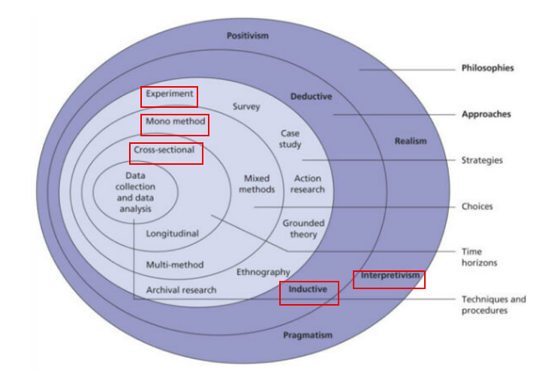
Figure 1: Research Onion Diagram

Background of this Research Theme
Dashboards are widely used to present complex information in a structured and visually accessible way, helping users identify trends, monitor key indicators, and interpret data more efficiently [1]. In financial contexts, dashboards are especially useful because they allow users to track and understand personal financial information through visual summaries [2].
As interface design has evolved, dashboards have increasingly included dynamic and interactive elements. Research shows that interface layout, interaction logic, and visual feedback can influence both usability and overall user experience [3]. However, studies comparing static and dynamic visual formats suggest that motion can improve engagement in some cases, while also making information harder to interpret in others [4].
For this reason, animation in dashboard design remains an important area of study. This research contributes to that discussion by examining how users perceive static and animated dashboards in terms of usability and engagement.

Hypothesis
Animation in Dashboards enhances visual interest but interferes with focus during analytical tasks

Research Aim and Purpose statement
The aim of this research is to investigate how animation influences user perceptions of usability and engagement in dashboard interfaces.

The purpose of this qualitative comparative study is to explore the influence of animation on perceived usability and engagement in financial dashboard interfaces for participants familiar with digital interfaces in a controlled usability testing setting.

Literature Review
This review examines how previous researchers have studied dashboards, user experience, and animated or static visual designs to identify common research strategies, key elements, and gaps. The studies referenced provide an understanding of how dashboard interfaces are designed, how usability and engagement are evaluated, and how animation may influence user perception.
A foundational approach to dashboard research is presented by Bach et al. [1], who analyse dashboards by identifying design patterns. Their study examines a large set of dashboards and categorises structures that occur repeatedly, layouts, and interaction components. This methodology is analytical and design-focused, aiming to understand how dashboards are typically constructed rather than how they are experienced by users. The strength of this approach is in its ability to reveal common design practices and highlight how different visual and functional elements are combined to support data presentation. By identifying patterns such as the structure of the layout, filtering, and visual hierarchies, Bach et al. [1] provide a strong theoretical foundation for dashboard design. However, the limitation of this method is that it does not involve user testing or direct interaction with participants. As a result, while it explains how dashboards are built, it does not address how users perceive usability or engagement, leaving a gap between design structure and user experience.
Young and Kitchen [5] provide a more user-focused methodological perspective, who explore dashboard design from the perspective and view of the audience. Their research adopts a user-centred approach, collecting qualitative feedback to understand how individuals interpret and interact with dashboards. This method is valuable because it recognises that dashboards are not only visual systems but also communication tools that must be understood by users. Young and Kitchin [5] use their findings to create design guidelines derived from real user experiences, highlighting factors such as clarity, accessibility, and interpretability. This approach contrasts with the design-driven method of Bach et al. [1], as it prioritises how users make sense of information rather than how it is structured. However, although this study provides important insight into usability and interpretation, it does not examine animation. The focus remains on general dashboard design principles, which means that the impact of animated versus static interfaces is not directly addressed.
Comparative methodologies are demonstrated in the work of Wang et al. [3], who study usability and user experience in the context of interface design software. Their research compares multiple systems based on factors such as interface layout, interaction logic, and usability. This approach is useful because it allows for an evaluation of different design alternatives, making it possible to identify strengths and weaknesses across systems. Wang et al. [3] show that usability can be assessed through structured comparison, where different interface conditions are analysed using consistent criteria. This is extremely relevant to the current research, which also involves comparing two interface types. The strength of this methodology is its ability to highlight differences between designs in a clear and systematic way. However, the limitation is that their study is focused on design software rather than dashboards.
The comparison between static and dynamic visual formats is explored more in the study by Shemy [4], who examines digital infographics. This research adopts an experimental approach, comparing static and dynamic formats to assess and evaluate how visual presentation affects users. Shemy [4] demonstrates that the format in which information is presented can influence how it is processed and understood, suggesting that motion can play a significant role in shaping user response. This is extremely relevant to the study, as it supports the idea that animation may affect usability and engagement. The strength of Shemy’s study comes from its focus on isolating visual format and allowing for a clear comparison between static and dynamic conditions. However, infographics differ from dashboards, since infographics are typically designed for presentation and storytelling, whereas dashboards are interactive systems used for monitoring and analysis.
Further insight into animation is provided by Ge et al. [6], who examine how users perceive animation in interface transitions. Their study focuses on the timing and smoothness of animated transitions, showing that different durations can influence how users experience interaction within an application. This research highlights that animation is not simply a visual addition, but a factor that can shape user perception and interaction. Ge et al. [6] demonstrate that poorly designed animation can negatively affect user experience, while well-timed transitions can improve the smoothness and usability of an interface. This is highly relevant to the current research, as it suggests that the impact of animation depends not only on its presence but also on how it is implemented. However, the study focuses on animation fluency rather than dashboard-specific tasks, meaning that its findings must be considered within the broader context of interface interaction.
From all these studies, several key elements can be identified. Bach et al. [1] focus on structural design elements and layout patterns, which define how dashboards are organised. Young and Kitchin [5] emphasise user interpretation, highlighting the importance of clarity and accessibility. Wang et al. [3] examine usability and user experience as outcomes of interface design, linking these factors to interaction quality. Shemy [4] focuses on visual presentation format, comparing static and dynamic conditions, while Ge et al. [6] analyse animation characteristics such as timing and fluency. These variables show that research in this area often centres on the relationship between design features and user perception.
The testing strategies used in these studies also vary depending on their research focus. Bach et al. [1] use analytical classification to identify patterns, which provides a broad understanding of dashboard design but does not include user interaction. Young and Kitchin [5] rely on qualitative user feedback, allowing them to explore how dashboards are experienced in practice. Wang et al. [3] use comparative testing to evaluate differences between interface designs, while Shemy [4] applies an experimental comparison to isolate the effects of static and dynamic presentation. Ge et al. [6] use controlled testing to examine how animation timing influences user perception. These strategies show that interface research often combines design analysis, user-centred evaluation, and controlled comparison to understand how different design choices affect user experience.
Despite the valuable contributions of these studies, several gaps still remain. Bach et al. [1] provide a strong understanding of dashboard design patterns, but do not address user perception. Young and Kitchin [5] explore usability and interpretation but do not examine animation. Wang et al. [3] offer a comparative methodology but in a different context, while Shemy [4] studies static and dynamic visuals outside of dashboard environments. Ge et al. [6] focus on animation fluency but do not link this directly to dashboard usability or engagement. This reveals a clear gap in the literature, as there is limited research that combines dashboard design, animation, usability, and engagement within a single study.
In conclusion, the reviewed literature demonstrates that a range of research methodologies have been used to study interface design. Each study provides an insight into different aspects of design and user experience, but none fully integrates the effects of animation within dashboard interfaces. Therefore, this current study aims to address this gap by comparing static and animated dashboard interfaces and exploring how these design choices influence user perception, usability, and engagement.

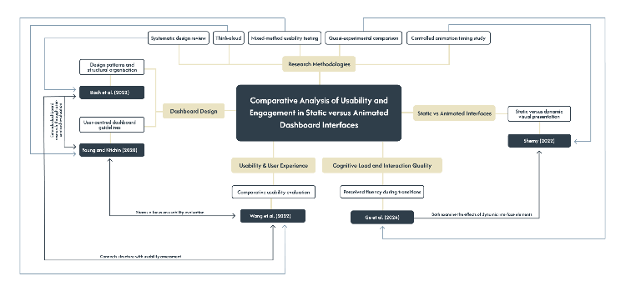
Figure 2: Literature Map

Research Methodology

Research Questions
1. How do static and animated dashboard interfaces differ in terms of usability?
2. How do static and animated dashboard interfaces differ in terms of user engagement?
3. To what extent does animation improve or hinder the overall user experience of dashboard interfaces?
Research Objectives
1. Design two dashboard interface versions, one static and one animated, with similar layout, content, and structure.
2. Test both dashboard versions with participants in order to compare their usability and engagement.
3. Collect user feedback and interaction data relating to clarity, ease of use, visual appeal, and overall experience.
4. Analyse whether animation contributes positively or negatively to the interface experience.
5. Identify design implications for future dashboard development based on the findings.
Research Philosophy
The reviewed literature show that interface research can be approached in different ways depending on the type of knowledge that wants to be achieved. Bach et al. [1] use a structured analytical approach by identifying recurring dashboard design patterns, while Wang et al. [3] and Ge et al. [6] rely on more controlled comparative methods to study usability and animation fluency. These studies are useful because they show how interface design can be examined systematically.
However, Young and Kitchin [5] take a more user-centred approach by using think-aloud sessions and the critical incident technique to understand how people experience dashboards. Their work is especially relevant because it focuses on user interpretation rather than only design structure. Although Shemy [4] compares static and dynamic visuals in a more structured way, the study still highlights that interface presentation shapes how users process and experience information.
This study follows an interpretivist philosophy, as it focuses on how participants perceive and interpret static and animated dashboard interfaces. It also adopts an inductive approach, since themes relating to usability, engagement, and visual clarity will emerge from observation and interviews rather than being reduced to numerical testing. Overall, the study sits within a qualitative, interpretive paradigm with a comparative focus [4], [5].
Chosen Methodology
The most suitable methodology for this research is a mono-method qualitative comparative study using observation and semi-structured interviews. This is appropriate because the study aims to explore users’ experiences in depth rather than measure them only through scores.
The literature supports this choice, Young and Kitchin [5] are the strongest influence because they show the value of exploring dashboards through direct user interaction and qualitative insight. Bach et al. [1] provide a useful understanding of dashboard structure, while Wang et al. [3] demonstrate the importance of comparison in usability research. Shemy [4] and Ge et al. [6] further support the relevance of comparing static and dynamic interface elements. Together, these studies suggest that comparison is important, and that user interpretation is equally important.
Description of the Chosen Research Methodology
The study will compare two dashboard interfaces: one static and one animated. Both versions will contain the same content, layout, and purpose, so that the main difference is the use of animation. This is important because dashboard structure itself affects user understanding and experience [1], [5].
Participants will interact with both versions during a single session and complete similar tasks. While they do so, an observation on their behaviour and interaction patterns will be occurring. Afterward, semi-structured interviews will be used to explore their views on usability, engagement, clarity, and overall preference.
This design fits the research objectives because it allows direct comparison while still capturing user experience. Observation helps reveal hesitation, confusion, or ease of use, while interviews allow participants to explain their views in their own words. This reflects the user-centred direction seen in Young and Kitchin [5] and also recognises the importance of dynamic visual effects discussed by Shemy [4] and Ge et al. [6].
The data will be analysed using thematic analysis. Observation notes and interview responses will be reviewed to identify repeated ideas and patterns, such as ease of navigation, distraction, clarity, engagement, and preference. This method suits the interpretivist and inductive nature of the study because it focuses on meaning drawn from participant experience.
Reflections on Validity, Reliability and Generalisability
Validity depends on ensuring that the dashboards differ only in animation and not in other design features such as layout or content. This is important because the reviewed literature shows that structure and presentation strongly influence user interpretation [1], [5]. If the two versions are not extremely similar, it will be difficult to know whether responses relate to animation or to another design change.
Reliability is more complex in qualitative research because people may not respond in the same way. However, it can be strengthened by using the same tasks, observation process, and interview questions for all participants. In this study, the aim is not identical answers, but a consistent process.
The findings are unlikely to be statistically generalisable, especially with a small sample. However, they may still offer transferable insights for similar dashboard design contexts. This is realistic for a small-scale qualitative study and aligns with the context-specific nature of the reviewed sources [4]–[6].
Ethical Considerations
Although the study is low risk, ethical issues still need to be considered. Participants must give informed consent and understand the purpose of the study, what they will do, and that participation is voluntary. Due to the fact that observation and interviews are used, participants should know that their behaviours and responses will be part of the research data [5].
Confidentiality must also be protected, therefore any notes, recordings, or transcripts will be anonymised and stored securely for academic use only.
A further ethical issue is participant comfort. Since the research compares static and animated interfaces, some users may find animation distracting or tiring. This concern is supported by Shemy [4] and Ge et al. [6], who both show that dynamic visuals can affect cognitive experience and perceived fluency. For this reason, the animated version should be designed carefully, and participants should be free to stop or withdraw at any time.

REFERENCES
[1] B. Bach et al., “Dashboard Design Patterns,” IEEE Transactions on Visualization and Computer Graphics, vol. 29, no. 1, pp. 1–11, 2022, doi: https://doi.org/10.1109/tvcg.2022.3209448.
[2] “Designing for User Engagement among Young Adults: Applying Design Thinking to develop a Financial Dashboard.” Available: https://www.diva-portal.org/smash/get/diva2:1788177/FULLTEXT01.pdf
[3] J. Wang, Z. Xu, X. Wang, and J. Lu, “A Comparative Research on Usability and User Experience of User Interface Design Software,” International Journal of Advanced Computer Science and Applications, vol. 13, no. 8, 2022, doi: https://doi.org/10.14569/ijacsa.2022.0130804.
[4] N. S. Shemy, “Digital Infographics Design (Static vs Dynamic): Its Effects on Developing Thinking and Cognitive Load Reduction,” International Journal of Learning, Teaching and Educational Research, vol. 21, no. 5, pp. 104–125, May 2022, doi: https://doi.org/10.26803/ijlter.21.5.6.
[5] G. W. Young and R. Kitchin, “Creating design guidelines for building city dashboards from a user’s perspectives,” International Journal of Human-Computer Studies, vol. 140, p. 102429, Aug. 2020, doi: https://doi.org/10.1016/j.ijhcs.2020.102429.
[6] Y. Ge, H. Chen, Y. Wang, W. Qu, Y. Zhang, and Y. Liu, “User perception of animation fluency: The effect of time duration in different phases of animated transitions during application usage,” International Journal of Human-Computer Studies, vol. 186, pp. 103257–103257, Jun. 2024, doi: https://doi.org/10.1016/j.ijhcs.2024.103257.
‌

‌

‌

